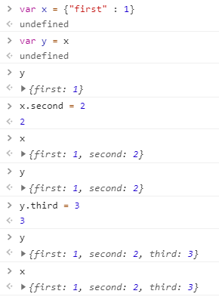

In js if we define two object variable x and y , and make x = y , then changing x attributes (x.something = somethings) will change the object y also and vice-versa. Please refer the above example. Note here we are assigning y = x that is entire object x’s reference is given in y , we are not assignig x.something to y.

Assigning x.something to another varaible such as k has different effect.

